TEAM ID: PNT2022TMID15125

TEAM LEADER: Vemula Srija

TEAM MEMBER 1: Yamala Himasree TEAM MEMBER 2: Pulimi Hemalatha

TEAM Member 3: J Sharmila

IBM CLOUD SERVICES

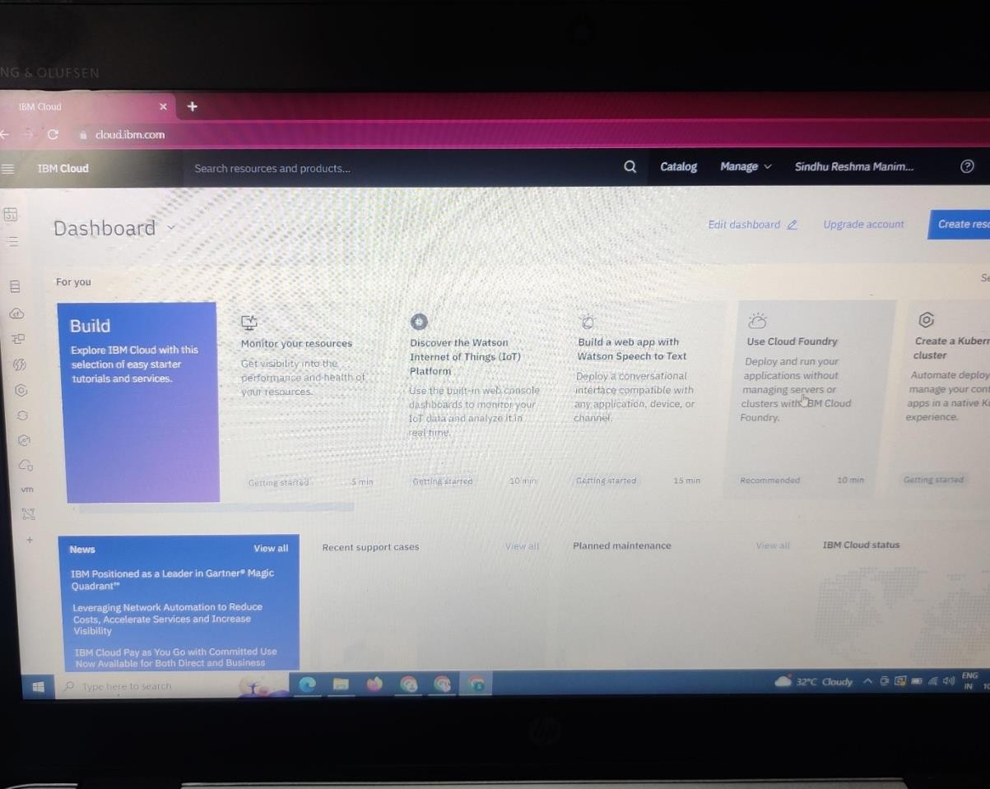

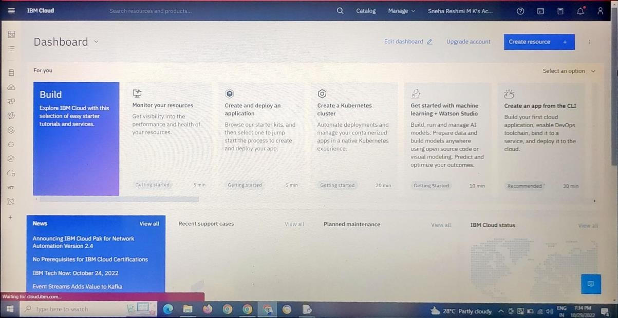

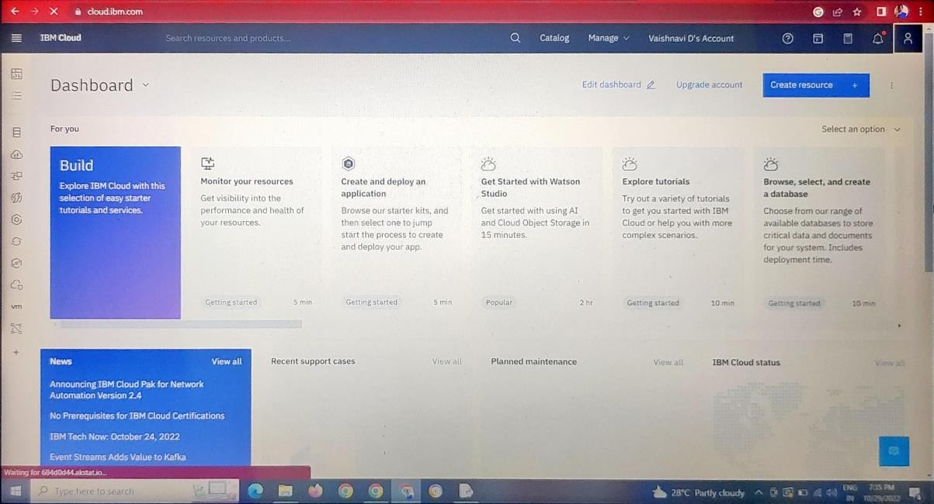

I

